Misr J. Ag. Eng., 26(4): 1776 - 1799 FARM MACHINERY AND POWER
MATHEMATICAL MODEL FOR PREDICTING VACUUM
PRESSURE OF ONION SEEDS PRECISION SEEDER
Afify M T* El-Haddad Z A** Hassan G E *** Shaaban YA****

ABSTRACT
The main objective of this paper was to develop a mathematical model for predicting the optimum vacuum pressure of a precision vacuum seeder using onion seed properties, vacuum characteristics and the hole geometry of seed plate. The onion seed properties were linear dimensions (length (L), width (W) and thickness (T)), one thousand seed mass (m), seed cross sectional area (A_{s}), projected area (A_{p}), geometrical mean diameter (D_{g}), sphericity (φ), seed density (ρ_{s}), repose angle (θ), the dynamic coefficient of friction (μ), terminal velocity (V_{t}) and the drag coefficient, (C_{d}). The vacuum characteristics were the vacuum velocity in general flow (V_{v}), vacuum density at normal temperature (ρ_{v}), vacuum pressure at normal temperature (P_{v}) and the Reynolds′s number (N_{Re}). The hole geometry of seed plate were the effective hole diameter (D_{o}), the radius in sink flow (R) and the conical entrance angle (α).
Experiments were carried out under laboratory and soil bin conditions. Laboratory experiments were conducted to determine the onion seed properties. Engineering calculations were performed for estimating the vacuum characteristics and also for calculating the hole geometry of seed plate. On the other hand, soil bin tests were carried out to verify the accuracy of developed model at various levels of blower (vacuum pump) speeds using three seed plates with different hole diameters. The blower speeds (BS) used were 4000, 4500, 5000 and 5500-rpm and the different hole diameters of seed plates were 0.8 mm, 1 mm and 1.2 mm.
Results indicated that the developed model could satisfactorily describe the parameters affecting on determining the vacuum pressure in the hole with correlation coefficients ranged from 0.97 to 0.99. It also showed that the final model could be used for predicting the optimum vacuum pressure of a precision vacuum seeder of onion seeds with an efficiency of 0.99

**Professor, * Lecturer, ****Graduate Student, Dept. of Agric. Eng. Moshtohor, Benha Uni. ***Director of The Agric. Eng. Res. Institute, ARC, Dokki , Giza , Egypt.

Table 1. Notations
A_{h} | conical entrance hole area, (mm²)
A_{o} | effective area of the hole, (mm²)
A_{s} | seed cross-sectional area, (mm²)
A_{p} | projected area of the seed, (mm²)
BS | blower speed, (rpm)
C_{d} | drag coefficient of the seed, (dimensionless)
D_{g} | geometrical mean diameter of onion seed, (mm)
D | diameter of the hole, (mm)
D_{o} | effective diameter of the hole, (mm)
D_{s} | diameter of spherical seed, (mm)
F_{c} | contact force between seed and the hole, (N/m)
F_{L} | lift force on seed created by pressure, (N)
g | acceleration of gravity, (m/s²)
K | coefficient defined in equation [9]
m | seed mass, (mg)
P | pressure difference across the hole, (kPa)
P_{b} | pressure for brush-off the seed, (kPa)
P_{d} | dynamic pressure corresponding to the terminal velocity of seed, (kPa)
P_{e} | pressure for ejection the seed, (kPa)
P_{h} | pressure in the hole, (kPa)
P_{hm} | minimum pressure for holding the seed, (kPa)
P_{pm} | minimum pressure for picking-up the seed, (kPa)
P_{s} | static pressure to hold seed against the force of gravity, (kPa)
P∞ | vacuum pressure at infinity, (kPa)
Q_{h} | vacuum discharge through hole, (cm³/s)
R | radius in sink flow, (mm)
V_{v} | vacuum velocity in general flow, (m/s)
V_{h} | vacuum velocity in the hole, (m/s)
V_{t} | seed terminal velocity, (m/s)
θ | repose angle, (degree)
α | conical entrance angle, (degree)
φ | Friction angle, (degree)
μ | dynamic coefficient of friction, (%)
μ_{v} | dynamic viscosity of the vacuum at normal temperature, (Pa.s)
ρ_{v} | vacuum mass density, (kg/m³)
ρs | seed mass density, (kg/m³)

INTRODUCTION
I
n resent years, precision planting has been a major drive of agricultural engineering research. However, most of the research and development work has dealt with seeders for agronomic crops. Several successful pneumatic seeders for large agricultural seeds are commercially available but precise metering of small horticultural seeds such as onion has been a problem due to large variations in seed shape and size. Rohrbach and Holmes (1970) demonstrated that a high velocity, low volume vacuum stream could be used to capture and singulate single spherical seeds in a cylindrical seeds cavity. Holmes (1985) also reported that an air-jet flowing into the apex of a conical cavity also retains a single spherical particle and allows a wide range of seed sizes to be used. Previous experimenters studying vacuum planters have used several kinds of seed pickup elements, such as nozzles (Moden and Jacobson, 1973), drum perforations (Bufton et al.,1974), perforated vacuum plate (Walters, 1971), and suction ports on a wheel periphery (Wanjura and Hudspeth, 1969). Generally, the pickup elements were passed through the seed hopper and captured a single seed. Fallak et al., (1984) reported that vacuum seeders work by an air pressure difference have five separate operations in the metering process. These were seed orientation, seed pickup, seed holding and transport, brush-off of extra seeds, and seed ejection. They added that the most important component of the vacuum seeders is the nozzle, which picks up seeds from the seed plate, carries the seed past the brush-off device and finally ejects the single seed into a discharge tube. They also reported that the nozzle may be considered as consisting of a body, an entrance section, an orifice and an air outlet section. Little information is available from published experiments about the optimum pressure required for picking up and holding the seeds, but Sweetman (1957) recommended 17 kPa working pressure for clover seeds and Hammond (1965) used 3 kPa for sugar beet and 15 kPa for beans. The ratio between the opening diameter of the seed plate of vacuum seeder and the diameter of the seed also has not been reported.
Nevertheless, the data available permit calculation of this ratio between a low value of 0.18 (Giannini et al., 1967) and a high value of 0.87 (Short and Huber, 1970). Although, the properties of seeds, which include physical, mechanical and aerodynamic properties, are the most important factor affecting in the design of metering mechanism of vacuum seeders, most types of these equipment have been designed based on the physical properties only. In addition, there are few numbers of models have been found to describe vacuum seeder parameters such as vacuum pressure related with the properties of seeds. Shafii and Holmes, (1990) developed two mathematical models for predicting the pressure distribution and forces exerting on the seed. They used spherical balls of various diameters to represent seeds. Results indicated that, the model derived from stagnation point flow and boundary-layer theory accurately predicted the pressure and forces on the seed for the 1.59 mm orifice over the range of cone-seed clearances yielding high retaining forces. Guarella et al., (1996) devised a mathematical model based on the general principals of fluid dynamics and valid for seeds with a round shape. They measured the maximum distance at which pick-up took place, when the vacuum depression was varied from zero to 80 kPa using four different types of seeds and seven different nozzles. They found that the experimental tests partly confirm the validity of the model, that is, up to depressions of about 48 kPa and with round-shaped seeds. Karayel et al., (2004) developed a mathematical model using some physical properties of different seeds. They found that the optimum vacuum pressure of a precision seeder were 4 kPa for maize; 3 kPa for cotton and soya bean; 2.5 kPa for watermelon and cucumber; 2 kPa for sugar beet and 1.5 kPa for onion seeds. They also added that the final model could satisfactorily describe the vacuum pressure of the precision vacuum seeder with a chi-square of 2.51 x 10⁻³, root mean square error of 2.74 × 10⁻² and modeling efficiency of 0.99. Therefore, the main objective of this paper was to developed a mathematical model for predicting the optimum vacuum pressure of onion seeds precision seeder using onion seed properties, vacuum characteristics and the hole geometry of seed plate. Specific objectives of this study were to:
- Develop analytical equations to predict the variables affecting on determining the theoretical vacuum pressure such as vacuum discharge, vacuum velocity in the hole, pressure difference across the hole, pressure for picking-up the seed, seed contact force per unit length of contact, seed static lift force due to the vacuum pressure difference, pressure for holding the seed and pressure at infinity.
- Measure the vacuum pressure in the hole and the vacuum velocity in general flow under different levels of blower speeds using three seed plates with different hole diameters.
- Evaluate the accuracy of the model in describing the vacuum pressure in the hole with the measured data.

MATERIALS AND METHODS
Laboratory Test Procedures
Laboratory test procedures were carried out at the Research Institute of Agricultural Engineering, ARC, during the year 2007. The physical, mechanical and aerodynamic properties of seeds were determined using a verity of uncoated Giza 20 onion seeds. The measured and calculated properties of onion seeds and also the vacuum characteristics are shown in Table 2. The onion seed properties and the vacuum characteristics were determined using the following methods:
- Linear dimensions, which include length (L), thickness (T) and the width (W) were measured using a digital caliper with a sensitivity of 0.01 mm.
- Geometrical mean diameter was calculated using the following equation.
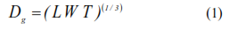
- Sphericity (φ) were calculated using Mohsenin equation (Mohsenin, 1986).
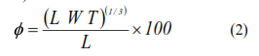
- One thousand seed mass was measured using an electronic balance with a sensitivity of 0.001 g.
- Seed density was determined using the liquid displacement method (Mohsenin, 1986).
- Projected area was determined using a digital camera and Auto CAD Program.
- Repose angle of onion seeds was determined using a digital instrument construct in the workshop of Agric. Eng. Department, Agric. Res. Center (ARC).
- The friction angle of onion seed on the surface of stainless steel 304 was determined using an instrument constructed in the workshop of Agric. Eng. Department, Agric. Res. Center (ARC). Then, the following equation used to calculate the dynamic friction coefficient:
- Terminal velocity and drag coefficient of onion seed were calculated using the following equation:
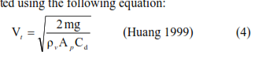
- The Ronald's number of the vacuum was calculated using the following equation:
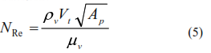
Soil bin Test Procedures
Tests were conducted at an indoor soil bin facility of the Department of
Agricultural Engineering, Mansoura University, during the year 2007. The precision vacuum pressure seeder was tested under four levels of vacuum velocities in general flow using three different seed plates with three hole diameters. The levels of blower speeds (BS) were 4000, 4500, 5000 and 5500-rpm. The different hole diameters were 0.8, 1.0 and 1.2 mm. Soil in the bin was sandy soil. The bin was 0.75 m wide, 5.7 m long, and 0.4 m depth. Vacuum pressure delivered to the seed plate was controlled with a variable speed drive electric motor that used to operate the blower (vacuum pump).
Table 2. Measured and calculated properties of onion seeds and the characteristics of vacuum.
Item | Sample1 |  | Sample2 | Sample3 |  | Mean | SD
Onion seed properties
Length, (mm) | 3.02∗ |  | 3.01∗ | 3.03∗ |  | 3.02 | 0.01
Width, (mm) | 2.08∗ |  | 2.13∗ | 2.12∗ |  | 2.11 | 0.03
Thickness, (mm) | 1.33∗ |  | 1.31∗ | 1.32∗ |  | 1.32 | 0.01
mean diameter, (mm) | 2.01∗ |  | 2.03∗ | 2.02∗ |  | 2.02 | 0.01
Sphericity (φ), (%) | 66.72∗ |  | 67.05∗ | 66.82∗ |  | 66.86 | 0.17
Projected area, (mm²) | 4.7∗ |  | 4.3∗ | 4.8∗ |  | 4.6 | 0.26
One thousand mass,(mg) | 4.49∗∗ |  | 4.47∗∗ | 4.51∗∗ |  | 4.49 | 0.02
Moisture content ,(%) | 8.96*** |  | 9.31*** | 10.4*** |  | 9.56 | 0.75
Seed density, (kg/m³) | 1247*** |  | 1249*** | 1254*** |  | 1250 | 3.61
Repose angle, (deg.) | 36.16*** |  | 36.01∗∗* | 35.91*** |  | 36.03 | 0.13
Coefficient of friction, (%) | 0.42*** |  | 0.46*** | 0.44*** |  | 0.44 | 0.02
Terminal velocity of seed, (m/s) | 5.94*** |  | 6.01*** | 5.89*** |  | 5.95 | 0.06
Drag coefficient, (dimensionless) | 0.422
Vacuum characteristics
Reynolds number, (dimensionless) | 908.03*** | 886.23*** |  |  | 925.43*** | 906.56 |  | 19.64
Vacuum density | 1.204 kg/m³
Vacuum pressure | 101.6 kN/m²
Dynamic viscosity of vacuum | 19.83 × 10⁻⁶ Pa..s
Vacuum velocity in general flow | 10 m/s | 12 m/s |  |  | 14 m/s | 16 m/s
*Average of 100 readings **Average of 10 readings ***Average of 5 readings

Measurements were taken for vacuum velocity in general flow and the vacuum pressure in the hole at various levels of blower speeds using different seed plates with three hole diameters.
A precision vacuum seeder unit (Figure 1) was fabricated under Egyptian conditions using local materials (stainless steel 304). The seeder unit was designed for planting two rows with 70 mm apart. Three seed plates with different hole diameters were fabricated from stainless steel 304 and used as the metering mechanism. The outer diameter of seed plate was 215 mm with 2 mm thickness. Eighty holes were drilled along 190 mm and 165 mm diameters of pitch circle for the first and the second rows, respectively. The seed plate operated in a vertical plane. The vacuum pressure in the hole measured by using a manometer with a sensitivity of 1.0 mbar. The vacuum velocity in general flow measured at different levels of blower speeds using a digital vacuum velocity instrument with a sensitivity of 0.1 m/s. The average values of the vacuum velocity in general flow were 10, 12, 14 and 16 m/s at 4000, 4500, 5000 and 5500rpm blower speeds, respectively.
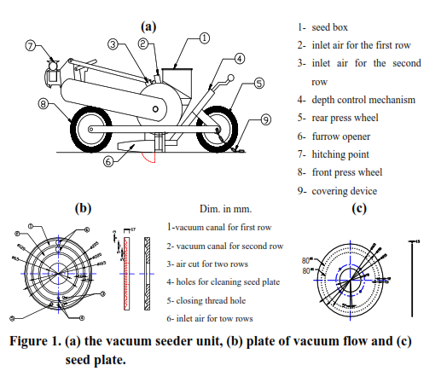

MODEL DEVELOPMENT

Seed Aerodynamic Properties
Fallak et al., (1984) stated that the seed can be held stationary inside an open-ended vertical tube, with an inside diameter slightly bigger than the seed diameter. If the static pressure forces acting on the projected area of the seed balance the gravity force, the pressure difference (P) between one point above and one below the seed being held in position in this static case is denoted by (P_{s}) and can be expressed by the following equation:
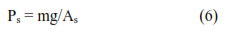
Under this study, it was assumed that the onion seed has a spherical shape, then the static pressure to hold the seed against the force of gravity cloud expressed as the following:

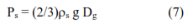
On the other hand, in the dynamic case of a seed suspended stationary in a vertical vacuum flow, the vacuum velocity must be equal to the terminal velocity of the seed (V_{t}). Thus, the pressure difference between a point in the atmosphere at rest and a point in the channel with the seed, creating that (V_{t}) is defined as the following:
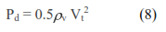
By combining equation (8) with the definition of terminal velocity from equation (4), it gives that:

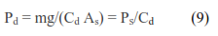

Vacuum Flow into a Hole
The converging vacuum flow into a hole represents a partial sink flow being controlled and contoured by the hole geometry (Shafii, 1981). Under this study, the vacuum flow in the hole is considered to be a radial flow. This is because the values of Reynolds number not exceeds by more than 906 (Table 2). It also assumed that the equipotential surfaces are spherical. Therefore, the vacuum velocity in this case (V_{v}) depends on the radial distance from the sink point. Three different hole diameters are used under this study. These produced three different conical entrance angles and three radiuses in sink flow as shown in Figure (2). For a conical entrance with angle (α), the conical entrance area of the hole and the velocity in general flow are expressed as the following:
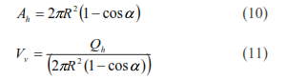

α = 21.8° α = 25.6° α = 29.2°
R = 1.6 mm R = 1.7 mm R = 1.8 mm
A_{h} = 1.2 mm² A_{h} = 1.8 mm² A_{h} = 2.6 mm²
Figure 2. Vacuum flow pattern into different holes.
From Bernoulli's equation between a point far away from the hole and the hole entrance, the pressure that causing the vacuum flow is expressed as the following:
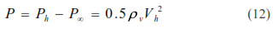
Where, the vacuum velocity in the hole (V_{h}) equal:
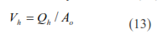

Pneumatic Picking-up
If a seed is resting at the center line of the vacuum flow below a hole at a distance (R) and has an undisturbed radial flow around it, it will be at the edge of pickup when V_{v} ≥ V_{t} (Fallak et al., 1984). Combining equations (11) and (12) produces a fourth power relationship between the pressure difference across the hole (P) and the radius in sink flow (R) as the following:
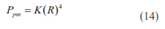
Sial (1978) stated that the pervious equation is not expected to apply at locations very close to the hole due to the disturbance by the seed to the vacuum flow. He added that when the seed leaves the seed plate and moves toward the hole along the joining vacuum flow, it achieves its highest velocity immediately before contacting the hole. He also assumed that the motion equations for the seed after pickup produced a non-linear non-homogeneous second order differential equation. He calculated the time for the seed center to reach within one radius from the sink point was approximately 25 ms and the seed velocity was only 3% of the seed terminal velocity. Consequently, impact damage to the seed was not expected.

Seed Held Against the Hole
In the analysis of the steady contact between the seed and the hole, both bodies are assumed to be rigid. Assuming a spherical seed and a hole with circular cross section, a line contact exists with contact and a friction force is illustrated in Figure (3).
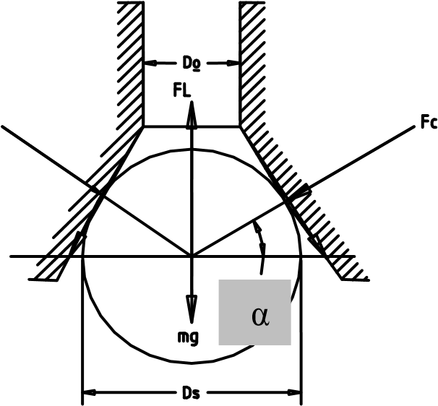

Figure 3. Forces on seed held against hole entrance section (after Fallak et al., 1984)

A seed could be held in the hole either against the conical surface of the entrance section or against the edge of the hole depending on the entrance section angle and the seed diameter. Seed contact against the hole entrance section occurs if the hole diameter D_{h} < D_{s} cos (α). When the seed closes the hole and the hole axis is vertical, the elemental contact forces are constant along the contact line. Therefore, the static lift force (F_{L}) due to the vacuum pressure difference (P) can be calculated using pressure difference across the hole and the cross sectional area of the contact circle as the following:
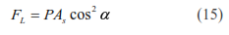
Static equilibrium was performed for the forces acting on the seed (Figure 2) with neglecting electrostatic forces, resulted in the following equation:
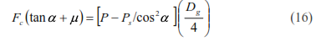
When the hole holding the seed makes an angle with the vertical, the contact force will vary along the contact line. Due to this non-symmetry, the minimum pressure needed to maintain contact all around will be higher than with that in the vertical case. Therefore, in this case the pressure difference for holding the seed (P_{hm}) when F_{c} = zero becomes:

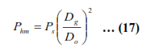

Seed-Hole Impact Forces
As the seed is picked up, it strikes the hole with an impact. Most of the impact energy absorbed by the seed in the form of plastic and elastic deformation energy (Sail and Persson 1979). In the second stage of the impact, the elastic forces in the seed try to push the seed out again. In this case, the friction forces work against the release force. The elastic energy is converted into kinetic energy of the seed and used to overcome the friction energy between the seed and the hole on its way out. Depending on the entrance section angle and the seed elastic deformability, the seed may wedge into the hole, because elastic energy is insufficient to overcome the friction. The vacuum pressure forces in this case help to prevent the seed from leaving the hole, or will quickly return the seed to the hole if it should leap out after the first impact.

Holding and Transporting Forces
The seed is subjected to inertial and vibrational forces during transport, and consequently it could be dropped even if P > P_{hm}. When the P is slightly larger than P_{hm}, and the seed temporarily loses contact with the hole, it can not be attached back to the hole since that requires a higher (P). Consequently, the holding (P) must always be appreciably greater than (P_{hm}) in order to retain at least one seed throughout the metering process.

Brush-off Forces
An additional force is exerted on the seed by the brush-off device. In case of a mechanical brush-off device, this force takes a value independent of the seed properties and determined by the rigidity of the device. However, in case of a pneumatic brush-off device, the force depends on the seed aerodynamic properties and the brushing vacuum velocity. Under this study, a plastic material used as a brush-off device, but unfortunately, it could not determine the brush-off force. To overcome this limitation, a vacuum velocity will be kept in a fixed ratio to the terminal velocity of the seed.

Ejection Forces
The seed should theoretically be ejected due to gravity when the (P) in the hole falls below (P_{hm}). In case of a wedged seed, however, the friction and adhesion forces caused by retained deformation of the seed may hold it in the hole as discussed above. The forces become significant for small values of (a) and if high (F_{c}) values were created during pickup. A reversed pressure difference or a mechanical pusher may be needed for reliable ejection.

Vacuum Pressure in the Hole
The vacuum pressure in the hole could be determined from equation (7) as the following:
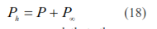
Under this study, it was assumed that, the vacuum pressure at infinity included static pressure to hold seed against the force of gravity (Ps), dynamic pressure corresponding to the seed terminal velocity (Pd), pressure for holding the seed (P_{hm}) and the pressure for picking-up the seed (P_{pm}). Therefore, the equation (18) becomes:
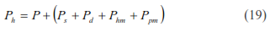
Equation (19) used for calculating the theoretical vacuum pressure in the hole as a function of other pressures affecting on the seed, which depended mainly on the seed properties, vacuum characteristics and the hole geometry of the seed plate.

Model Program
An interactive computer program was developed and written by Microsoft Quick Basic as a computer language. This program used to determine the variables affecting in determining the predicted vacuum pressure in the hole. The input data required for the model are the properties of onion seeds and the characteristics of vacuum. The flowchart of this program is shown in Appendix (A).

Model Verification
The developed model was verified by conducting soil bin experiments using a precision vacuum seeder unit. Tests were carried out under four levels of blower speeds using three seed plates with different hole diameters. The blower speeds were 4000, 4500, 5000, and 5500-rpm. The hole diameters of seed plates were 0.8, 1.0 and 1.2 mm. Measurements were taken for the vacuum velocity in general flow (V_{v}) and the vacuum pressure in the hole (P_{h}). The computer model developed here in this study has been used to derive theoretical equations for calculating the variables affecting in determining the theoretical vacuum pressure in the hole using the input parameter (seed properties and the vacuum characteristics). The results obtained from the model were compared with that from experimental results. Details of these results are given below.

RESULTS AND DISCUSION
In order to determine the theoretical vacuum pressure in the hole, the developed model used to predict the variables affecting on determining the theoretical vacuum pressure using analytical equations. These variables were vacuum discharge through the hole, vacuum velocity in the hole, pressure difference across the hole, pressure for picking-up the seed, seed contact force per unit length, seed static lift force due to the vacuum pressure difference, pressure for holding the seed and vacuum pressure at infinity. On the other hand, the measured vacuum pressure was determined under various levels of blower speeds and by using three seed plates with different hole diameters.

Predicted vacuum discharge through the hole
Figure (4) shows the effect of the hole diameter on the predicted vacuum discharge through the hole at various levels of blower speeds. It is indicated that, the predicted vacuum discharge through the hole increased as the hole diameter increased for different blower speeds. The highest values of the predicted vacuum discharge through the hole were obtained with the seed plate of 1.2 mm hole diameter at 5500-rpm blower speed. However, the 0.8 mm hole diameter resulted in the lowest values of the vacuum discharge through the hole. These results may be attributed to the increasing in the conical entrance area (equation 5) as the hole diameter increased from 0.8 mm to 1.2 mm. For 1.0 mm hole diameter, the predicted vacuum discharge through the hole increased as the blower speed increased. This is due to the increasing in the vacuum velocity in general flow (equation 6), which may cause increase in the vacuum discharge through the hole.

Predicted vacuum velocity in the hole
The predicted vacuum velocity in the hole decreased as the hole diameter increased at different blower speeds (Figure 5). However, it was increased with increasing in the blower speeds. The change in the hole diameter from 0.8 mm to 1.2 mm does not produce much decrease in the predicted vacuum velocity in the hole. However, for 1.0 mm hole diameter, the predicted vacuum velocity in the hole increased by 38% when the blower speed increased from 4000-rpm to 5500-rpm. These results duo to the increasing in the predicted vacuum discharge (Figure 4) as the blower speed increased.

Predicted pressure difference across the hole
The effect of the hole diameter on the predicted pressure difference across the hole at different blower speeds is shown in Figure (6). As expected, the predicted pressure difference across the hole decreased as the hole diameter increased. This is duo to the increasing in the hole effective area as the hole diameter increased. On the other hand, the predicted pressure difference across the hole increased with an increase in the blower speed. This is duo to the increasing in the vacuum velocity in the hole as the blower speed increased.

Predicted pressure for picking-up the seed
Similar trends were obtained in the predicted pressure for picking-up the seed as a compared with the predicted pressure difference across the hole at various levels of blower speeds and by using different hole diameters (Figure 7) except for the following differences:
- The increase in the hole diameter from 0.8 mm to 1.2 mm produced a decrease of 14% in the predicted pressure for picking-up the seed at any level of the blower speed.
- For 1.0 mm hole diameter, the increasing in the blower speed from 4000-rpm to 5500-rpm produced an increase in the predicted pressure for picking-up the seed by about 61%.
These results duo to that the factors affecting in determining the pressure for picking-up the seed depended on many quantities such as radius in sink flow, conical entrance angle, seed terminal velocity, effective hole diameter and the vacuum mass density.

Predicted static lift force and the contact force per unit length
According to Figure (2), the forces acting on the seed held against the hole include static lift force due to the vacuum pressure difference (F_{L}), the contact force per unit length of contact (F_{c}) and the weight of the seed (mg). Therefore, data in Figures (8 and 9) show the effect of the hole diameter on the static lift force and the contact force at various levels of blower speeds. Both forces decreased as the hole diameter increased. However, the increase in the blower speed from 4000-rpm to 5500-rpm produced an increase by 62% for both forces using the seed plate of 1.0 mm hole diameter. It also was noticed that the values of both forces close to zero that means there is no reversed pressure difference might be deformed (Fallak et al., 1984). Consequently, there is no need for mechanical pusher to eject the seed. These results duo to that the static lift force depends on the vacuum pressure difference, the cross sectional area of the seed and the conical entrance angle of the hole. However, the contact force per unit length of contact, which resulted from the static equilibrium with neglecting electrostatic forces, depends not only on the previous factors acting on the static lift force but also on the geometrical mean diameter of seed and dynamic coefficient of friction for the seed.

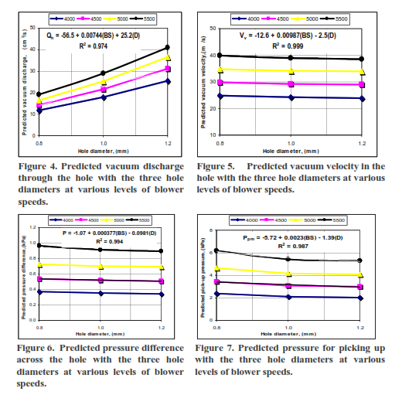

Predicted vacuum pressure for holding the seed
The predicted vacuum pressure for holding the seed against the hole is a function of static pressure to hold seed against the force of gravity, geometrical mean diameter of seed and the effective hole diameter (equation 12). Figure (10) shows that an increase in the hole diameter resulted a decrease in the vacuum pressure for holding the seed against the hole. The decrease in the vacuum pressure for holding the seed against the hole was 47% when the hole diameter increased from 0.8 mm to 1.2 mm.

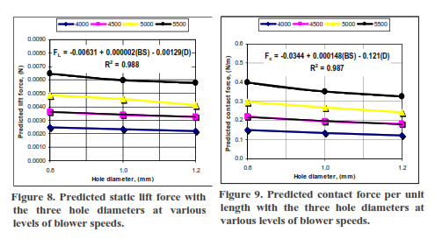

Predicted vacuum pressure at infinity
Figure (11) shows the effect of the hole diameter on the predicted vacuum pressure at infinity at various levels of blower speeds. Similar trends were obtained in the predicted vacuum pressure at infinity as a compared with the predicted vacuum pressure for holing and picking up the seeds (Figures 7 and 10). These results may have been attributed to the following reasons:
- The static and dynamic pressures have been taken constant values for different hole diameters.
- The pressure for holding the seed decreased as the hole diameter increased.
- The pressure for picking-up the seed decreased as the hole diameter increased at any level of the blower speed. However, it was increased as the blower speed increased at different hole diameters.

Predicted vacuum pressure in the hole
Figure (12) shows the effect of the hole diameter on the predicted vacuum pressure for different blower speeds. It is indicated that, the predicted vacuum pressure in the hole increased as the blower speed increased for different hole diameters. The highest values of the predicted vacuum pressure in the hole were obtained with the 0.8 mm hole diameter at different blower speeds. However, there is none potential variation in the predicted vacuum pressure in the hole between 1.0 mm and 1.2 mm hole diameters at different blower speeds. The increasing in the blower speed from 4000-rpm to 5500-rpm produced an increase in the predicted vacuum pressure in the hole by about 60% for 1.0 mm hole diameter. These results may have been attributed to the following reasons:
- The predicted vacuum pressure at infinity increased as the blower speed increased for different hole diameters (Figure 11).
- The predicted pressure difference across the hole increased as the blower speed increased for different hole diameters (Figure 6).
Relative between predicted and measured vacuum pressure in the hole.
Figure (13) shows the relation between predicted and measured vacuum pressure in the hole at various levels of blower speeds using the three seed plates with different hole diameters. It shows that, the final model could satisfactorily predict the vacuum pressure in the hole of a precision vacuum seeder for onion seeds with an efficiency of 0.99.

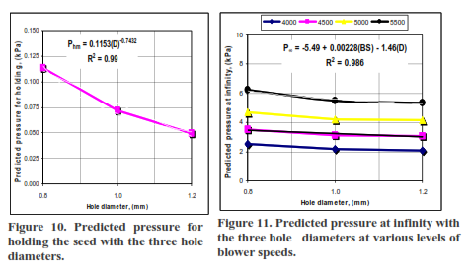

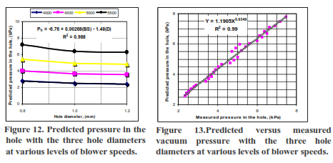

CONCLUSIONS
Based on the results of this study, it could be concluded that:
- Theoretical derived equations for calculating the variables affecting in determining the theoretical vacuum pressure in the hole showed that:
  - The values of the predicted vacuum discharge through the hole ranged from 1.8×10⁻⁵ m³/s to 2.88×10⁻⁵ m³/s for the seed plate of 1.0 mm hole diameter under different blower speeds.
  - There was no change in the predicted vacuum velocity in the hole by changing the hole diameter. However, as expected, it increased from 24.3 m/s to 38.4 m/s as the blower speed increased from 4000-rpm to 5500-rpm for the seed plate of 1.0 mm hole diameter.
  - The predicted static pressure to hold seed against the force of gravity and the dynamic pressure corresponding to seed terminal velocity were 16.51 Pa. and 37.35 Pa. These values are in agreement with previous finding by Fallak el al., (1984).
  - The predicted pressure difference across the hole does not increase by more than 963.2 Pa. under experimental conditions.
  - The average value of the predicted pressure for picking-up the seed (3.1 kPa.) was resulted at 4500-rpm blower speed using the seed plate of 1.0 mm hole diameter.
  - The values of the static lift force due to the vacuum pressure difference and the contact force per unit length of contact values were close to zero, which means no reversed pressure difference might be deformed and there is no need to eject the seed mechanically (Fallak el al., 1984).
  - The predicted vacuum pressure for holding the seed against the hole were 113.6, 71.6 and 49.7 Pa. for 0.8, 1.0 and 1.2 mm hole diameters, respectively.
  - The average value of the predicted pressure in the hole (3.6 kPa.) was resulted at 4500-rpm blower speed using the seed plate of 1.0 mm hole diameter.
- The relation between predicted and measured vacuum pressure in the hole at various levels of blower speeds using different hole diameters showed that, the final model could satisfactorily predict the vacuum pressure in the hole of a precision vacuum seeder for onion seeds with an efficiency of 0.99.
- The model developed in the current study could be also used to predict the vacuum pressure in the hole for other vegetables seeds that have properties like onion seeds.

REFERENCES
Bufton L P; Richardson P; O'Dogherty M J (1974). Seed displacement after impact on a soil surface. J. Agric. Eng. Res. 19(4):327-338.
Fallak S S; Sverker P. (1984). Vacuum nozzle design for seed metering. Transactions of the ASAE., 688-696.
Giannini G R; Chancellor W J; Garrett R E (1967). Precision planter using vacuum for seed pickup. Transactions of the ASAE, 10 (5): 607-610, 614.
Guarella P; Pellerano A; Pascuzzi S (1996). Experimental and theoretical performance of a vacuum seeder nozzle for vegetable seeds. Agric. Eng. Res. 46, 29-36
Hammond J E (1965). Precision vacuum type planter head. USDA-ARS 42-115.
Holmes R G (1985). Seed planter, planter assembly and method of picking up and discharging single seeds. U.S. Patent No. 4,515,291.
Huang J (1999). "Speed of skydiver" (Terminal velocity)". The physics Factbook. Glenn Elter, Midwood High School, Brooklen Collage.
Karayel D; Barut Z B; Ozmerzi A (2004). Mathematical modeling of vacuum pressure on a precision seeder. Biosystems Engineering. 87 (4):437-444.
Moden W L; Jacobson R S (1973). Planter for nursery seedbeds. ASAE Paper No. 73-1545, ASAE, St. Joseph, MI 49085.
Mohsenin N N (1986). Physical properties of plant and animal materials. Gordon and Breach Science Publishers, New York. USA.
Rohrbach R P; Holmes R G (1970). Anew concept in seed metering. ASAE Paper Number 70-108. St. Joseph, MI: ASAE.
Shafii S; Holmes R G (1990). Air-jet seed metering, a theoretical and experimental study. Transactions of the ASAE., 33 (5): 1432-1438.
Short T H; Huber S G (1970). The development of planetary-vacuum seed metering device. Transactions of the ASAE 13(6):803-805.
Sial F S (1978). Design of nozzles for horticultural vacuum planters. Ph.D. Thesis, The Pennsylvania State University, University Park, 194 pp.
Sial F S; Persson S P E (1979). Optimum design of vacuum planter metering mechanisms. ASAE Paper No. 79-1075, ASAE, St. Joseph, MI 49085.
Sweetman I C (1957). A suction operated precision planter. N. Z. J. of Sci. and Tech. A38(6):577-582.
Walters J (1971). Precision sowing of forest tree seed for container planting. Transactions of the ASAE 14(6):1136-1138.
Wanjura D F; Hudspeth E B (1969). Performance of vacuum wheels metering individual cotton seeds. Transactions of the ASAE 12(6):775-777.
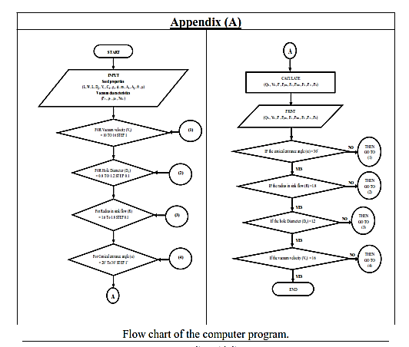

الملخص العربي
نموذج رياضي للتنبؤ بضغط الھواء السالب لآلة زراعة دقيقة تناسب حبوب البصل
محمد تھامي عفيفي* زكريا عبد الحمن الحداد** جمال السيد حسن*** يسري عبد القوي شعبان****

إن تصميم أجھزة التلقيم لمعدات الزراعة الدقيقة التي تعمل بشفط الھواء يعتمد على عدة عوامل منھا: الخصائص المختلفة للحبوب Physical, mechanical and aerodynamic properties)) - خصائص الھواء (Vacuum characteristics)- الأبعاد الھندسية لفتحات الھواء في قرص التلقيم - الضغط السالب الذي ينتج بواسطة مضخات الھواء والمسئول عن التقاط الحبوب ونقلھا وأخيرا دفعھا إلى أنابيب البذور. وبالرغم من توافر كثيرا من معدات الزراعة الدقيقة التي تعمل بشفط الھواء على المستوى التجاري ، إلا أن معظم ھذه المعدات تستخدم للحبوب الكبيرة لأنه مازال استخدامھا مع الحبوب الصغيرة مثل البصل يواجه بعض الصعوبات والتي تعود إلى الاختلافات الكبيرة في أشكال وأحجام تلك الحبوب بالإضافة إلى أن معظم تلك المعدات تم تصميمھا اعتمادا على خصائص الحبوب الفيزيقية فقط. ونظرا لمحدودية عدد النماذج الرياضية التي توضح العلاقة بين الضغط السالب للھواء والخواص المختلفة للحبوب خصوصا الصغيرة منھا: {Shafii and Holmes, 1990; Guarella et al., (1996) and Karayel et al., (2004)}
لذا فإن الھدف من ھذه الدراسة ھو تطوير نموذج رياضي يمكنه التنبؤ بالضغط السالب للھواء على فتحات قرص التلقيم باستخدام كلا من الخصائص المختلفة لحبوب البصل - خصائص الھواء - الأبعاد الھندسية لفتحات الھواء في قرص التلقيم. وللوصول لھذا الھدف تم اجراء تجارب معملية لتقدير الخصائص المختلفة لحبوب البصل كما تم اجراء تجارب في معمل التربة لتحقيق فاعلية النموذج باستخدام وحدة زراعة دقيقة لبذور البصل تحت مستويات مختلفة من سرعات مضخة الھواء (Blower speeds) وباستخدام ثلاثة أقراص تلقيم ذات فتحات للھواء مختلفة الأقطار كما تم أيضا اجراء حسابات ھندسية لتقدير أبعاد فتحات الھواء في قرص التلقيم وتقدير بعض خصائص حبوب البصل. وكانت أھم النتائج التي تم التوصل إليھا كما يلي:
- إن المعادلات التجريبية التي تم استنتاجھا لتقدير العوامل التي تؤثر على الضغط السالب الناتج على فتحات البذور أظھرت مايلي:
  - القيمة المثلى لتصرف الھواء داخل الفتحة يجب ألا تقل عن 1.8 ×10⁻⁵ m³/s وأن لاتزيد عن2.88 ×10⁻⁵ m³/s لفتحة الھواء ذات القطر 1.0 mm تحت المستويات المختلفة من سرعات مضخة الھواء.
  - لا يوجد تغيير ملحوظ في سرعة الھواء داخل الفتحة كلما تغير قطرھا ، بينما زادت سرعة الھواء داخل الفتحة كلما زادت سرعة مضخة الھواء.
  - قيمة الضغط الساكن لحمل بذرة البصل ضد الجاذبية الأرضية كانت 16.51Pa. ، بينما كانت للضغط الديناميكي الناتج عن السرعة الحرجة للبذور 37.35 Pa..
  - إن فرق الضغط الأمثل خلال الفتحة Pressure difference across the hole يجب ألا يزيد عن 963.2 Pa.
  - القيمة المثلى للضغط اللازم لالتقاط البذرة كانت 3.1 kPa. عند 4500-rpm سرعة مضخة الھواء وباستخدام قرص التلقيم ذو القطر 1.0 mm.
  - قيمتا زاويتي الرفع الاستاتكي وكذلك زاوية التماس تحت المستويات المختلفة من سرعة المضخة وباستخدام الأقراص المختلفة للتلقيم كانتا قريبتين جدا من الصفر مما يعني أنه ليس ھناك ضرورة لوجود طارد ميكانيكي للحبوب.
  - القيمة المثلى للضغط اللازم لحمل البذرة ضد الفتحة يجب ألا تقل عن 49.7Pa. وأن لاتزيد عن 113.6Pa. لفتحات الھواء المختلفة.
  - القيمة المثلى للضغط السالب على الفتحة كانت 3.6 kPa. عند 4500-rpm سرعة مضخة الھواء وباستخدام قرص التلقيم ذو القطر 1.0 mm.
- إن العلاقة بين القيم النظرية والأخرى المقاسة للضغط السالب على الفتحة أظھرت أن النموذج يمكنه التنبؤ بالضغط السالب على الفتحة لآلات زراعة البصل التي تعمل بشفط الھواء بكفاءة قدرھا 0.99.
- بناءا على نتائج ھذه الدراسة فإنه يمكن التوصية باستخدام النموذج الذي تم تطويره للتنبؤ بقيم الضغط السالب علي الفتحة للمحاصيل التي تتشابه الخصائص المختلفة لحبوبھا مع حبوب البصل.

* مدرس بقسم الھندسه الزراعية بمشتھر- جامعة بنھا
** أستاذ بقسم الھندسة الزراعية بمشتھر- جامعة بنھا
*** مدير معھد بحوث الھندسة الزراعية
**** باحث مساعد بمعھد بحوث الھندسة الزراعية

